ASSIGNMENT 3

1. Arithmetic Operators

+ | Addition | Use to add two operands
– | Subtraction | Use to subtract two operands
-expr | Unary Minus | It is Use to reverse the sign of the expression
* | Multiply | Use to multiply two operands
/ | Division | Use to divide two operands
~/ | Division | Use two divide two operands but give output in integer
% | Modulus | Use to give remainder of two operands

2. Equality and Relational Operators

> | Greater than | Check which operand is bigger and give result as boolean expression.
< | Less than | Check which operand is smaller and give result as boolean expression.
>= | Greater than or equal to | Check which operand is greater or equal to each other and give result as boolean expression.
<= | less than equal to | Check which operand is less than or equal to each other and give result as boolean expression.
== | Equal to | Check whether the operand are equal to each other or not and give result as boolean expression.
!= | Not Equal to | Check whether the operand are not equal to each other or not and give result as boolean expression.

3. Type test Operators

is | is | Gives boolean value true as output if the object has specific type
is! | is not | Gives boolean value false as output if the object has specific type

4. Bitwise Operators

& | Bitwise AND | Performs bitwise and operation on two operands.
| | Bitwise OR | Performs bitwise or operation on two operands.
^ | Bitwise XOR | Performs bitwise XOR operation on two operands.
~ | Bitwise NOT | Performs bitwise NOT operation on two operands.
<< | Left Shift | Shifts a in binary representation to b bits to left and inserting 0 from right.
>> | Right Shift | Shifts a in binary representation to b bits to left and inserting 0 from left.

5. Assignment Operators

= | Equal to | Use to assign values to the expression or variable
??= | Assignment operator | Assign the value only if it is null.

6. Logical Operators

&& | And Operator | Use to add two conditions and if both are true than it will return true.
|| | Or Operator | Use to add two conditions and if even one of them is true than it will return true.
! | Not Operator | It is use to reverse the result.

7. Conditional Operators

condition ? expersion1 : expersion2 | Conditional Operator | It is a simple version of if-else statement. If the condition is true than expersion1 is executed else expersion2 is executed.
expersion1 ?? expersion2 | Conditional Operator | If expersion1 is non-null returns its value else returns expression2 value.

8. Cascade Notation Operators

.. | cascading Method | It is used to perform multiple methods on the same object.

condition ? expersion1 : expersion2 | Conditional Operator | It is a simple version of if-else statement. If the condition is true than expersion1 is executed else expersion2 is executed.
expersion1 ?? expersion2 | Conditional Operator | If expersion1 is non-null returns its value else returns expression2 value.

Q2
import "dart:io";

void main() {
int ticketprice = 600;
print("How many tickets you Buy?");
int mans = int.parse(stdin.readLineSync()!);
int buy = ticketprice * mans;
print("Total cost of ticket is $buy");
}

Ans
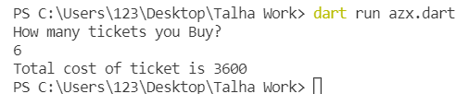
Q3
void main() {
List<dynamic> ft = [1, 2, 3, 4, 5, 6, 7];
List<dynamic> tf = [3, 5, 6, 7, 9, 10];

ft.removeWhere((item) => tf.contains(item));
print(ft);
}
Ans
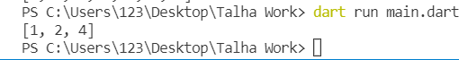
Q4
7. Conditional Operators

condition ? expersion1 : expersion2 | Conditional Operator | It is a simple version of if-else statement. If the condition is true than expersion1 is executed else expersion2 is executed.
expersion1 ?? expersion2 | Conditional Operator | If expersion1 is non-null returns its value else returns expression2 value.

8. Cascade Notation Operators

.. | cascading Method | It is used to perform multiple methods on the same object.

condition ? expersion1 : expersion2 | Conditional Operator | It is a simple version of if-else statement. If the condition is true than expersion1 is executed else expersion2 is executed.
expersion1 ?? expersion2 | Conditional Operator | If expersion1 is non-null returns its value else returns expression2 value.

Q5

Data Type | Keyword | Description
Number | int, double, num | Numbers in Dart are used to represent numeric literals
Strings | String | Strings represent a sequence of characters
Booleans | bool | It represents Boolean values true and false
Lists | List | It is an ordered group of objects
Maps | Map | It represents a set of values as key-value pairs

Q6
import "dart:io";

void main() {
var tseven = [7, 14, 21, 28, 35, 42, 49, 56, 63, 60];
var table = [1, 2, 3, 4, 5, 6, 7, 8, 9, 10];
var data = Map.fromIterables(table, tseven);
print(data);
}
Ans
Q7
import "dart:io";

void main() {
var JS = "123asd";

print("Enter Your Password: ");
var pass = stdin.readLineSync();
if (pass == "") {
print("Please Enter Your Password");
} else if (JS == pass) {
print("Correct");
} else if (JS != pass) {
print("Incorrect Password");
}
}

Ans
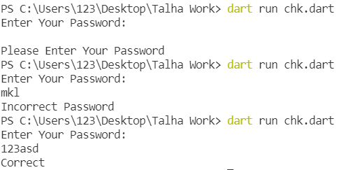
Q8
import "dart:io";
import "dart:math";

void main() {
var TMarks = 500;
var SName = ["Talha", "Asif", "Asad"];
var Sstore = [298, 367, 455];
var data = Map.fromIterables(SName, Sstore);
print(data);

Q9
1) Variable name can consist of letter and alphabets.
- Keywords are not allowed to use as a variable name.
- Blank spaces are not allowed in variable name.
- First character of variable should always be alphabet and cannot be digit.
- Variable name are case sensitive i.e. UPPER and lower case are .) significant.
- Special characters like #, $ are not allowed except the underscore (_) and the dollar ($) sign.

Q10
import "dart:io";
void main() {
String ft = "Hyderabad";
String tf = ft.replaceAll("Hyder", "Islam");
print(tf);
}

Ans
Q11
import "dart:io";
void main() {
stdout.write("Customer Name: ");
var CName = stdin.readLineSync();
stdout.write("Current Month: ");
var CMonth = stdin.readLineSync();
stdout.write("Number of Units: ");
num NUnits = num.parse(stdin.readLineSync()!);
stdout.write("Charge per Unit: ");
num CUnits = num.parse(stdin.readLineSync()!);
num NetPayA = NUnits * CUnits;
print("Net Payable Amount $NetPayA");
num LatePS = 500;
num GrossAPay = NetPayA + LatePS;
print("Gross Payable Amount $GrossAPay");
}
Ans
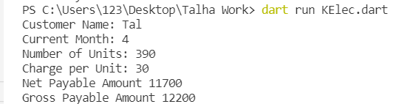
Q12
import "dart:io";
void main() {
int date = int.parse(stdin.readLineSync()!);
if (date < 16) {
print("Fifteen days of the Month");
} else {
print("Last day of the Month");
}
}
Ans

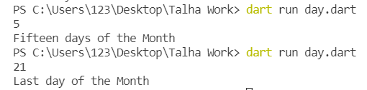

Q13

List Methods

- shuffle():
- reversed:
- asMap():
- whereType():
- getRange():
- replaceRange():
- firstWhere():

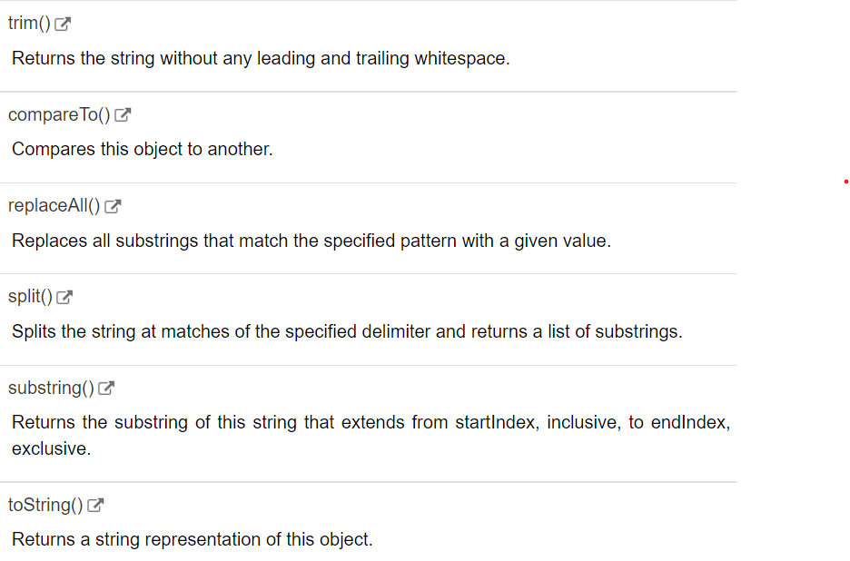
String Method

